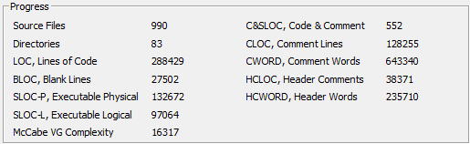

jfreechart-master v1.50

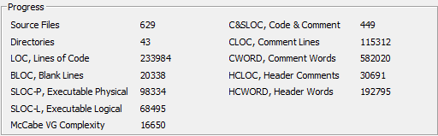

jfreechart-1.0.19

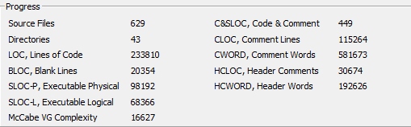

jfreechart-1.0.18